Internationale Deutsche Taekwon-do ITF

Meisterschaft 2020


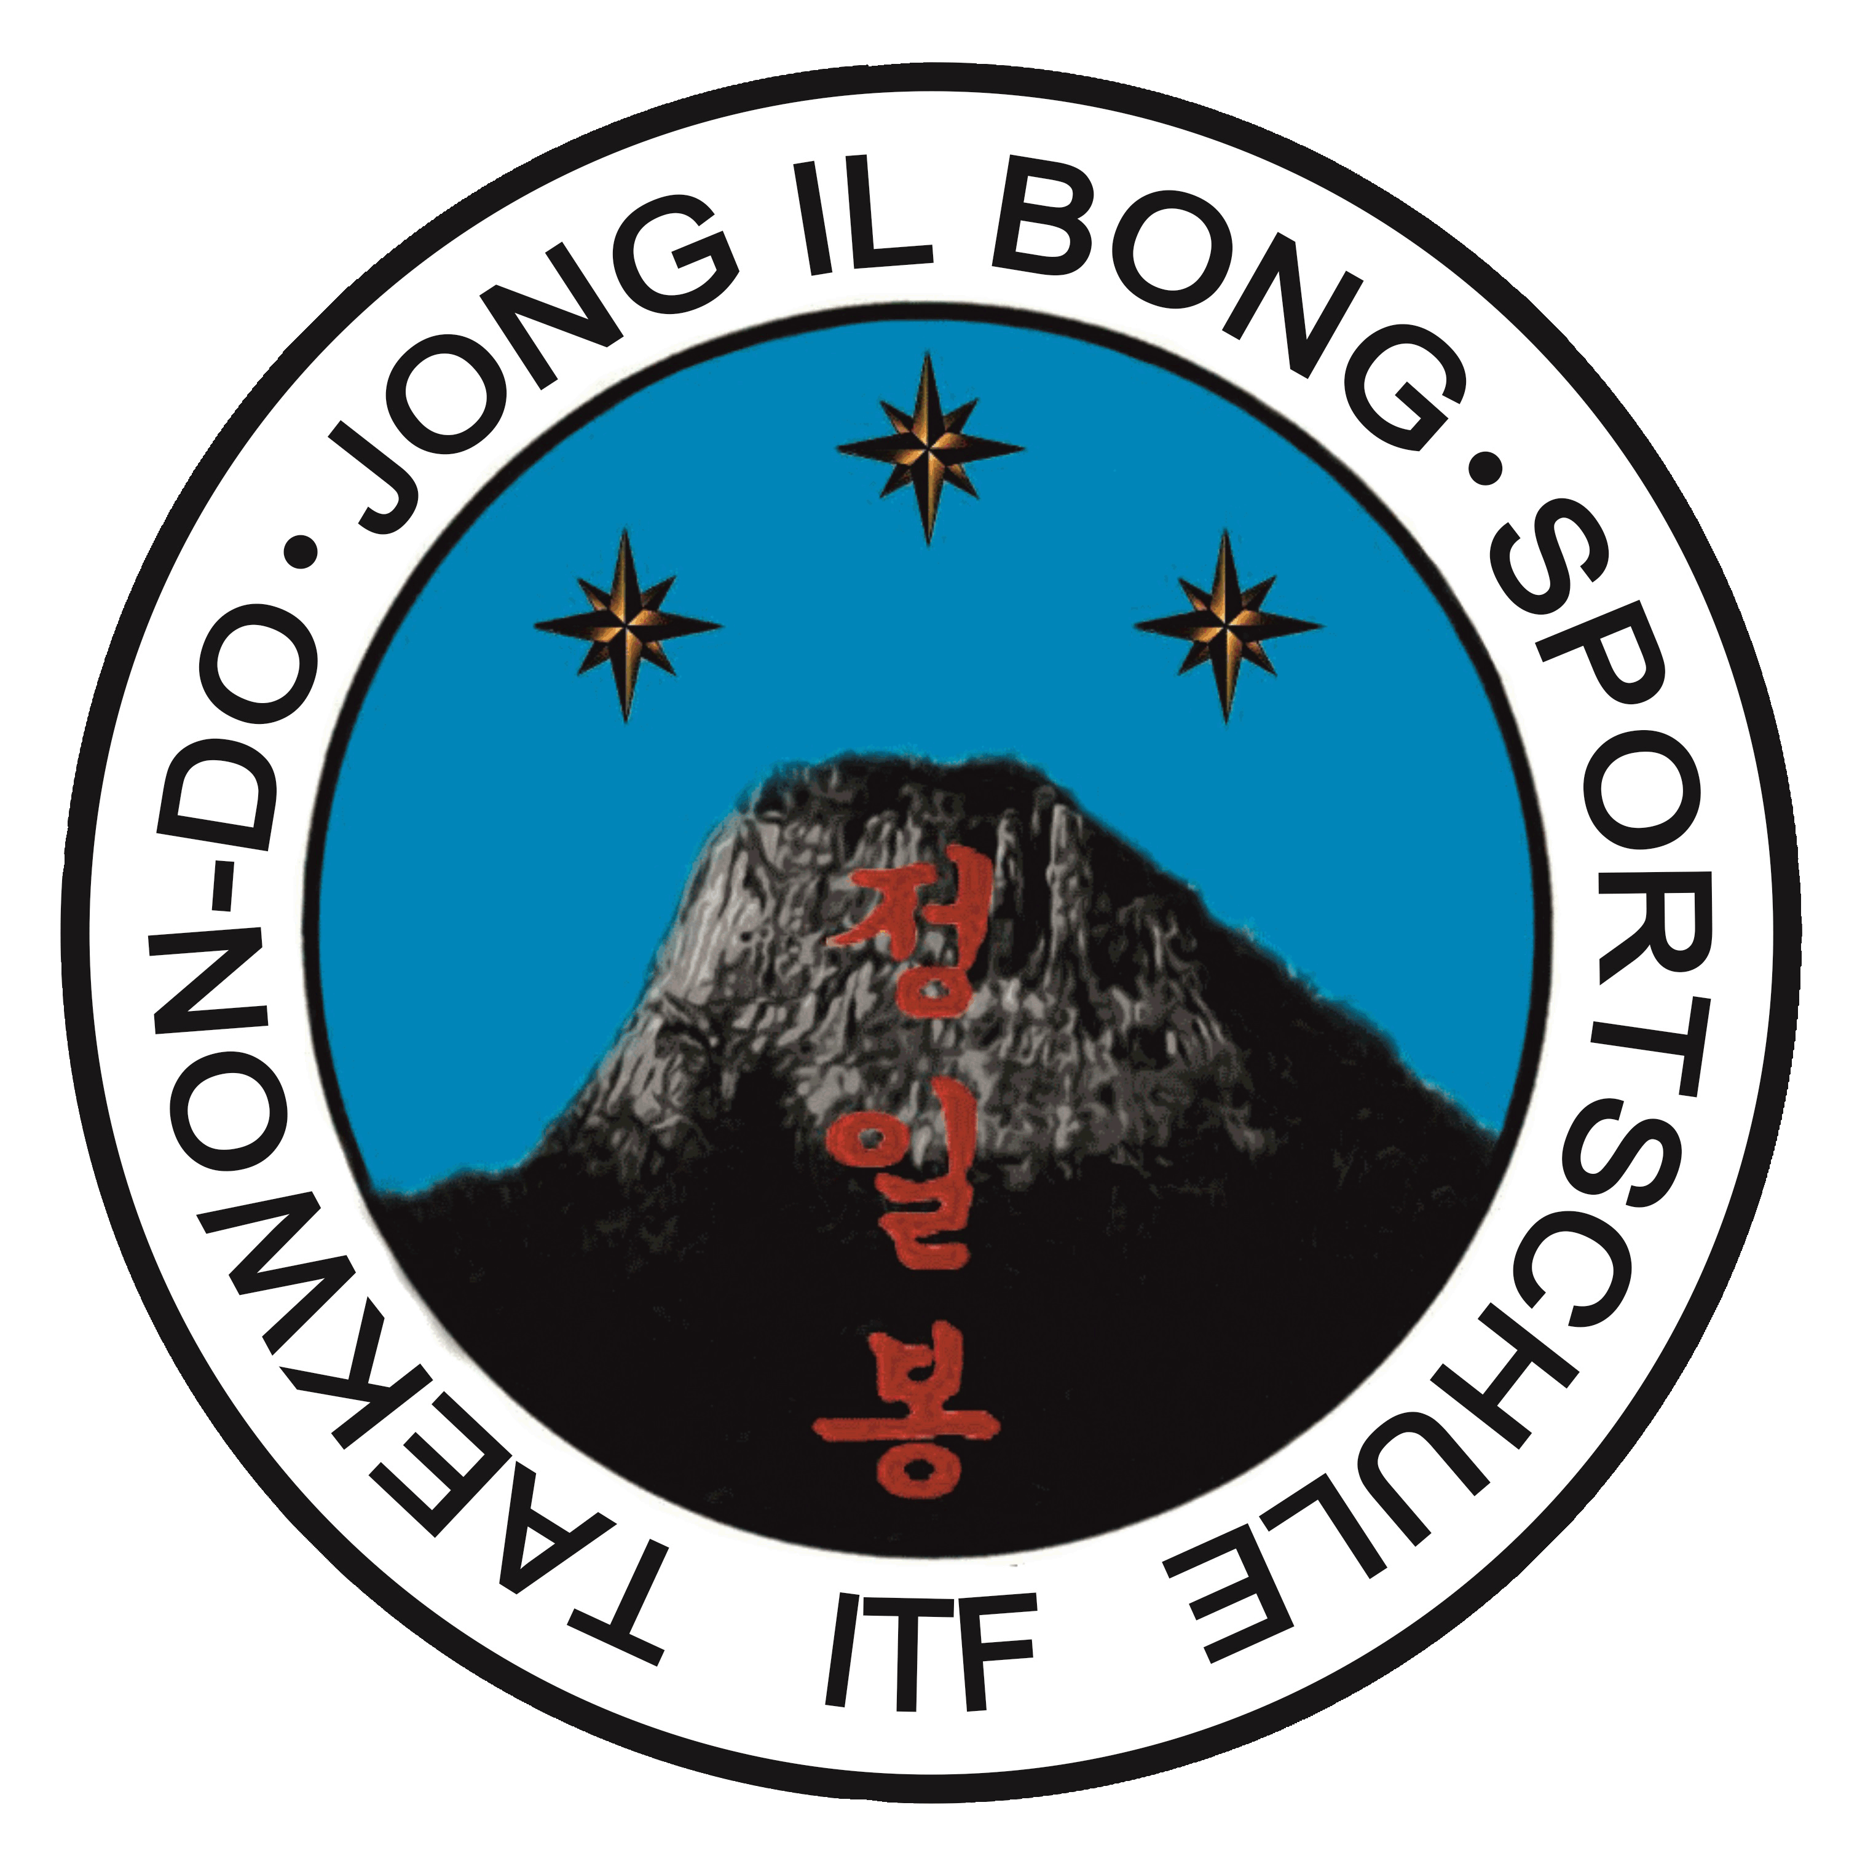


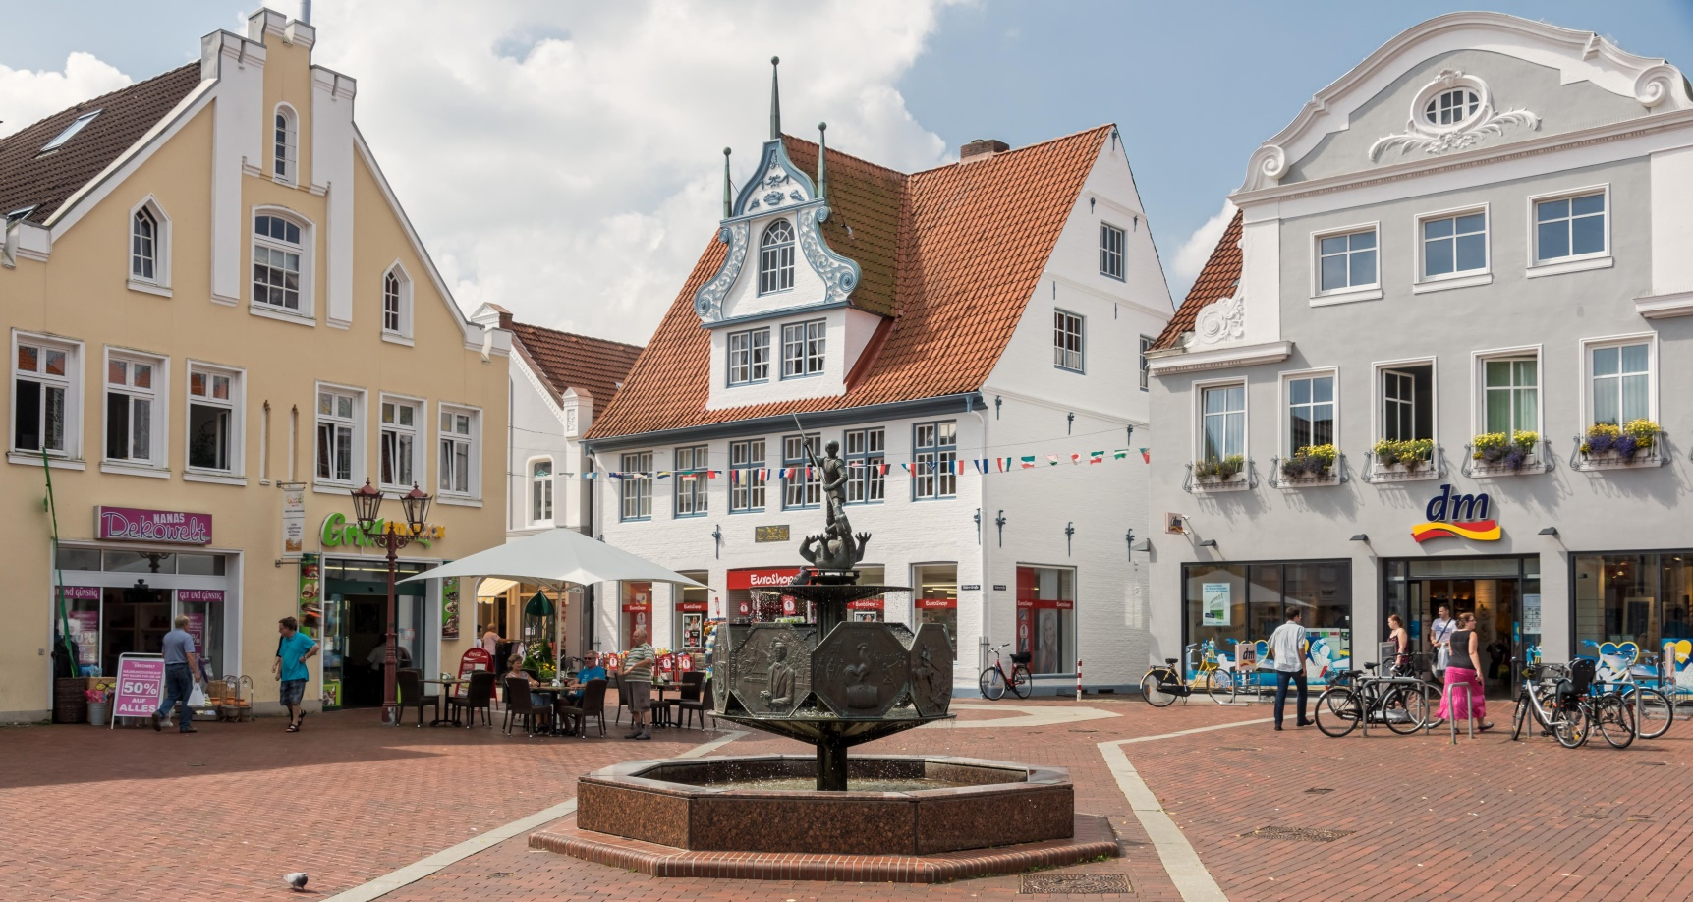


28-29 MARCH 2020
______________________________

HEIDE, GERMANY

O F F I C I A L P O S I T I O N

GENERAL INFORMATION

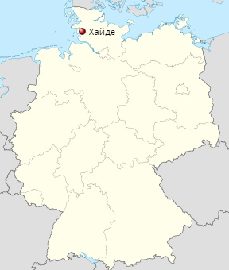
Heide, Germany

The city of Heide is located in northern Germany in the federal state of Schleswig-Holstein, 15 km from the North and 80 km from the Baltic Sea. Known as a tourist city on the North Sea. In the center of the city is the largest market square in Germany (4.7 g), on which a trading market with seafood, farm products, souvenirs has been open continuously for more than 500 years on Saturdays. Around the market square there are numerous cafes, pastry shops, restaurants, shopping centers, a museum, a cinema, a concert hall.
The city is connected by direct rail / bus and motorway to the international airport of Hamburg (100 km), Berlin (390 km), Hanover (260 km).


COMPETITORS

Representatives of national sports organizations - members of the International Taekwon-do Federation ITF have the right to participate in the international taekwondo tournament. Competitors must have the appropriate age (at least 6 years old in the relevant groups on the day of registration), the appropriate qualifications (at least 9 Kup, at most 6 Dan), documents confirming age and qualification, ITF passport, as well as medical admission and contract insurance. Each sports delegation must submit an original application for this form. Each sports delegation can be represented by any number of athletes.
The final registration list must be entered no later than 02.29.2020.

REGISTRATION AND QUESTIONS

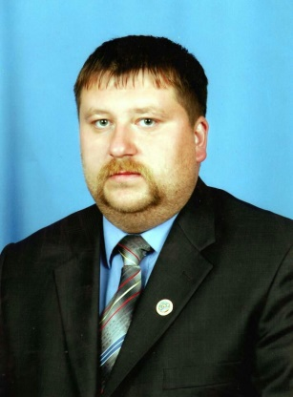
President NGB ITF Alexander Hauptfleisch

D-25746 Heide

Tel: +49/172/9238797
Email: alexanderhauptfleisch74@gmail.com

ORGANIZIR
MTV von 1869 Heide e.V.
Ludwig-Ehrig-Stadion Am Sportplatz 1 D-25746 Heide

Taekwon-do Sports Shool „JONG IL BONG“ 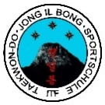

DATE

28-29 March 2020

LOCATION

Helmut-Lanzke-Halle, Bürgemeister-Vehrs-Straße, D-25746 Heide

PARTICIPATION FEE

30 euros for the 1st athlete
40 euros for the 1st athlete (after the application deadline)

50 euros for 1 team
60 euros for 1 team (after the application deadline)

PROTEST
A protest can only be submitted by a team representative.
The protest is filed with a security deposit of 50 euros.
Upon satisfaction of the protest, the deposit is refunded.
If the protest is rejected, the deposit will not be refunded.
Video recordings when considering a protest are not accepted.
Teams that did not provide referees for the tournament,
are deprived of the right to protest.

JUDGES

Each team must provide one judge.
The organizing committee assumes the costs of placing one judge,
if the team is more than 15 athletes.

RULES
ITF Taekwondo Rules as amended
on the day of the competition.

COMPETITION PROGRAMM

Competitions are held for the following types of programs:

- personal competitions in Tuls (complex formal exercises):

Before the finals, the athlete performs one custom Tul.
In the finals, the athlete performs the maximum.
their qualifications and custom.

- personal competitions in Matsogi (Sparring):

Any number of athletes from the team can participate, but only in one age group and one weight category.

Duration of fights:

7-8 years - 2 rounds of 1 min., A break of 30 seconds;
9-10 years - 2 rounds of 1.5 minutes each, a break of 30 seconds;
11-13 years - 2 rounds of 1.5 minutes each, a break of 30 seconds;
14 - 17 years - 2 rounds (2 minutes each); 1 minute break
18 - 39 years old - 2 rounds (2 minutes each); 1 minute break
40 - 49 years - 2 rounds (1 min. 30 sec.); 1 minute break

Protective equipment:
gloves of the established sample (with closed fingers and an open palm);
protective protectors on feet (feet) of the established sample;
protective tire (cap);
a protective helmet of an established pattern (with a closed upper part);
girls 11-49 years old - a protective bib under a Dobok jacket;
protective bandage for Dobok pants.
shin protection.

Each participant must have outdoor protective equipment.
red and blue. Equipment of a different color is not allowed.
Each athlete must have an established ITF Dobok.

- team competitions in Tuls (complex formal exercises):

In team competitions, until the final, the team performs one Tul.
optionally, in the final, the team performs a custom and custom Tul.
Any number of teams can participate in the team Tul.

- Matsogi team competitions (fights):

Any number of teams can take part in team sparring.

ARE GROUPS, DIVISIONS, WEIGHT CATEGORIES

CHILDREN 6 YEARS
Sparring
Weight | Boys | Girls | Division
Super light | - 20 kg | - 20 kg | 1 Division  10-8 Kup
Light | - 23 kg | - 23 kg | 1 Division  10-8 Kup
Middle | - 26 kg | - 26 kg | 1 Division  10-8 Kup
Light heavy | - 29 kg | - 29 kg | 1 Division  10-8 Kup
Heavy | - 32 kg | - 32 kg | 1 Division  10-8 Kup
Super heavy | + 32 kg | + 32 kg | 1 Division  10-8 Kup

CHILDREN 7-8 YEARS
Tul
1 Division 9-5 Kup |  | Chon-Ji / Yul-Gok
2 Division 4-1 Kup |  | Chon-Ji / Choong-Moo
Sparring
Weight | Boyg | Girls | Division
Super light | - 23 kg | - 23 kg | 1 Division  9-5 Kup  2 Division  4-1 Kup
Light | - 26 kg | - 26 kg | 1 Division  9-5 Kup  2 Division  4-1 Kup
Middle | - 29 kg | - 29 kg | 1 Division  9-5 Kup  2 Division  4-1 Kup
Light heavy | - 32 kg | - 32 kg | 1 Division  9-5 Kup  2 Division  4-1 Kup
Heavy | - 35 kg | - 35 kg | 1 Division  9-5 Kup  2 Division  4-1 Kup
Super heavy | + 35 kg | + 35 kg | 1 Division  9-5 Kup  2 Division  4-1 Kup

CADETS 9-10 YEARS
TUL
1 Division 9-5 Kup |  |  | Chon-Ji / Yol-Gok
2 Division 4-1 Kup |  |  | Chon-Ji / Choong-Moo
MATSOGI
Weight | Boys |  | Girls | Division
Super light | - 26 kg |  | - 26 kg | 1 Division  9-5 Kup  2 Division  4-1 Kup
Light | - 29 kg |  | - 29 kg | 1 Division  9-5 Kup  2 Division  4-1 Kup
Middle | - 32 kg |  | - 32 kg | 1 Division  9-5 Kup  2 Division  4-1 Kup
Light heavy | - 35 kg |  | - 35 kg | 1 Division  9-5 Kup  2 Division  4-1 Kup
Heavy | - 40 kg |  | - 40 kg | 1 Division  9-5 Kup  2 Division  4-1 Kup
Super heavy | + 40 kg |  | + 40 kg | 1 Division  9-5 Kup  2 Division  4-1 Kup
Team Tul / Team Sparring
Boys
Girls
Cadets 11-13 YEARS
TUL
1 Division 6-3 Kup |  | Chon-Ji / Toy-Gye
2 Division 2 Kup -1 Dan |  | Chon-Ji / Ge-Baek
Sparring
Weight | Кадеты | Кадетки |  | Division
Super light | - 35 kg | - 30 kg |  | 1 Division  6-3 Kup  2 Division  2 Kup -1 Dan
Featherweight | - 40 kg | - 35 kg |  | 1 Division  6-3 Kup  2 Division  2 Kup -1 Dan
Light | - 45 kg | - 40 kg |  | 1 Division  6-3 Kup  2 Division  2 Kup -1 Dan
Middle | - 50 kg | - 45 kg |  | 1 Division  6-3 Kup  2 Division  2 Kup -1 Dan
Light heavy | - 55 kg | - 50 kg |  | 1 Division  6-3 Kup  2 Division  2 Kup -1 Dan
Heavy | - 60 kg | - 55 kg |  | 1 Division  6-3 Kup  2 Division  2 Kup -1 Dan
Super heavy | + 60 kg | + 55 kg |  | 1 Division  6-3 Kup  2 Division  2 Kup -1 Dan
TEAM TUL/TEAM SPARRING
Boys
Girls

JUNIORS 14-17 YEARS
Tul 14-17 Years
1 Division 4-1 Kup |  |  |  | Chon-Ji / Choong-Moo
2 Division 1 Dan |  |  |  | Chon-Ji / Ge-Baek
3 Division 2-3 Dan |  |  |  | Chon-Ji / Choi-Yong
Team Tul 14-17 Years
Boys
Girls
Sparring 14-15 Years
Weight |  | Boys |  | Girls | Division
Super light |  | - 45 kg |  | - 40 kg | 1 Division  4-1 Kup  2 Division  1-2 Dan
Featherweight |  | - 50 kg |  | - 45 kg | 1 Division  4-1 Kup  2 Division  1-2 Dan
Light |  | - 55 kg |  | - 50 kg | 1 Division  4-1 Kup  2 Division  1-2 Dan
Middle |  | - 60 kg |  | - 55 kg | 1 Division  4-1 Kup  2 Division  1-2 Dan
Light heavy |  | - 65 kg |  | - 60 kg | 1 Division  4-1 Kup  2 Division  1-2 Dan
Heavy |  | - 70 kg |  | - 65 kg | 1 Division  4-1 Kup  2 Division  1-2 Dan
Super heavy |  | + 70 kg |  | + 65 kg | 1 Division  4-1 Kup  2 Division  1-2 Dan
Team Sparring 14-15 Years
Boys
Girls
Sparring 16-17 Years
Weight | Boys |  | Girls |  | Division
Super light | - 45 kg |  | - 40 kg |  | 1 Division  1-3 Dan
Featherweight | - 51 kg |  | - 46 kg |  | 1 Division  1-3 Dan
Light | - 57 kg |  | - 52 kg |  | 1 Division  1-3 Dan
Middle | - 63 kg |  | - 58 kg |  | 1 Division  1-3 Dan
Light heavy | - 69 kg |  | - 64 kg |  | 1 Division  1-3 Dan
Heavy | - 75 kg |  | - 70 kg |  | 1 Division  1-3 Dan
Super heavy | + 75 kg |  | + 70 kg |  | 1 Division  1-3 Dan
Team Sparring 16-17 Years
Boys
Girls

ADULTS 18-39 YEARS
Tul
1 Division 1-2 Dan |  | Chon-Ji/ Juche
2 Division 3-4 Dan |  | Chon-Ji/Moon-Moo
Sparring
Weight | Men | Women | Division
Super light | - 52 kg | - 47 kg | 1 Division  1-4 Dan
Featherwight | - 58 kg | - 52 kg | 1 Division  1-4 Dan
Light | - 64 kg | - 57 kg | 1 Division  1-4 Dan
Middle | - 71 kg | - 62 kg | 1 Division  1-4 Dan
Light heavy | - 78 kg | - 67 kg | 1 Division  1-4 Dan
Heavy | - 85 kg | - 72 kg | 1 Division  1-4 Dan
Super heavy | - 92 kg | - 77 kg | 1 Division  1-4 Dan
Absolute | + 92 kg | + 77 kg | 1 Division  1-4 Dan
Team Tul / Team Sparring
Men
Women

VETERANS 40-49 YEARS
Tul
1 Division 1-3 Dan |  | Chon-Ji / Choi-Yong
2 Division 4-6 Dan |  | Chon-Ji / Tong-Il
Sparring
Weight | Men | Women | Division
Light | -64 kg | -54 kg | 1 Division  1-6 Dan
Middle | -73 kg | -61 kg | 1 Division  1-6 Dan
Light heavy | -80 kg | -68 kg | 1 Division  1-6 Dan
Heavy | -90 kg | -75 kg | 1 Division  1-6 Dan
Super heavy | + 90 kg | +75 kg | 1 Division  1-6 Dan

REGISTRATION / WEIGHING
Registration and weighting of participants will take place at the address of the teams.
For registration and weighing the following documents are required:
- the established application form of the specified sample;
- a contract (original) for life insurance and accident insurance for each participant during the competition;
- ITF certificate or ITF passport confirming the qualification of the participant;
- identity document;

PARTICIPANTS ACCOMMODATION
Participants will be posted by the Organizing Committee in accordance with preliminary applications submitted before February 29, 2020.

Nordika Hotel
www.nordicahotel-heide.de

Jugendherberge Heide
www.heide.jugendherberge.de

Karstens Gasthof
www.karstens-gasthof.de

Koll‘s Gasthof
www.kolls-gasthof.de

VISA SUPPORT

To obtain a visa for Germany, you must contact the nearest German consulate.
The duration of the visa varies depending on the country of residence.
Participants applying for visas must provide the Organizing Committee with a list of names, surnames, date of birth, current citizenship, name and address of the host institution in Germany, time of stay (from arrival to departure), passport number, passport validity period, invitation from the Organizing Committee.

AWARDING / NATIONAL ANTHEM / FLAG

For the award ceremony, the athlete must be in ITF uniform or his team uniform; other clothing is not allowed.
Each country must provide the Organizing Committee with a record of its national anthem on a CD (45 seconds), national flag (size 100 x 150 cm).

COMPETITION PLAN

27.03.2020
Arrival and accommodation of participants
Registration and weighting

28.03.2020
Registration and weighing 08.00 - 09.00
Referee briefing 08.30 - 09.30
Start of competition 10.00
Opening 12.00 - 13.00
Rewarding

29.03.2020
Competition 10.00 - 19.00
Rewarding

WELCOME TO GERMANY

Internationale Deutsche Taekwon-do ITF Meisterschaft
28-29.03.2020
Helmut - Lanzke - Halle, Bürgermeister-Vehrs-Straße, D-25746 Heide

REGISTRATION

Team
City, Country
Phone/email
Representative

№ | Name,first name | Date of birth | M/W | Kup/Dan | Weight | Tul | Sparring | Team Sparring | Team Tul
6 years
 |  |  |  |  |  | - | + | -
 |  |  |  |  |  | - | - | -
7-8 years
 |  |  |  |  |  |  | - | +
 |  |  |  |  |  |  | - | -
9-10 years
11-13 years
14-15 years
16-17 years
18-39 years
40-49 years

Umpire
Name, first name | Position | Dan

